**EXAMINATION VERIFICATION SYSTEM USING BIOMETRICS FOR COMPUTER SCIENCE DEPARTMENT KADUNA POLYTECHNIC**

**PREPARED BY:**

**AISHAT YAHAYA**

**CST20HND0740**

**SUPERVISED BY:**

**DR. HAMISU I.A**

**NOVEMBER 2022**

**1.1 BACKGROUND OF THE STUDY**

Information and communication technology are one of the many sectors throughout the world that are growing in Nigeria. An examination is a formal exam that students take to demonstrate their knowledge of a specific subject, which is usually done in written form at Kaduna polytechnic that comprises a set of questions to be answered and will be used in grading the student.

According to a recent study by (Patrick et al., 2019) The process of determining the truth, correctness, or validity of anything, such as the verification of official papers, is known as verification.

Realistic authentication such as biometrics is a type of physical or behavioral human features that may be used to digitally identify a person in order to get access to systems, devices, or data. (Korolov, 2019).

(Korolob, 2019) relates to studies conducted recently that biometrics has the ability to significantly improve business security by providing a fair degree of confidence in authenticating a person with reduced friction for the user. When computers and gadgets recognize the fingerprints of an authorized user, they can unlock automatically. When trusted system administrators' faces are recognized, server room doors can swing open. When a help desk system recognizes an employee's voice on the support line, it may instantly pull up all pertinent information.

The security of biometric authentication data is critical, perhaps more so than password security, because passwords may be quickly altered if they are revealed. A fingerprint or retinal scan, on the other hand, is unchangeable. The publication of this or other biometric information might endanger users indefinitely and expose the corporation that loses the data to considerable legal liability (Korolob, 2019).

As there are several forms of biometric verification fingerprint biometrics verification will be employed in carrying out the research topic.

**1.2 STATEMENT OF THE PROBLEM**

Impersonation happens frequently in the computer science department at Kaduna polytechnic students can attest to this, but no one would want to sell out the person, even if the management makes sure there’s no loose end for students to carry out such dubious acts like laminating the examination card, the student can still make ways to manipulate things. For example, identical twins from different departments can come in and write exams for his/her second without the invigilator knowing.

Students can actually change passports on the examination card to any other person’s passport so the person can come into the examination hall to write the exam for them just to attain a good result even though the examination card has been laminated but still students can do anything to get what they want, But with the help of an examination biometric verification system, such acts will be difficult to carry out because each student will need to verify his/her identity before going to the exam hall.

**1.3 AIM AND OBJECTIVES**

To develop an **examination verification system using biometrics** for the department of computer science at Kaduna polytechnic.

**OBJECTIVES**

The objectives of this research work are as follows:

1. Upon opening of the newly admitted student file, the administrator would register the student and include their fingerprint in the system, this is how the data set will be generated.
2. The modern languages used in implementing this system is VB.net, and the FastCode (SDK) for finger identification to connect with the Digital Persona U 4500 fingerprint scanner.
3. In storing and retrieval of the collected dataset; MySQL which is an open-source relational database, will be used as the database technology.
4. Vital testing will be carried out in ensuring the efficacy of the research work

**2.1 LITERATURE REVIEW**

A Verification Tool for Preventing Impersonation of Students in Examination Halls using Fingerprints. A recent study by (Haruna, U. S. 2018) describes the design and implementation of an easy, secure, and efficient examination verification tool based only on students' fingerprints, with the goal of streamlining associated operations and eliminating the possibility of impersonation as a form of examination malpractice. The program was created in Visual Basic (VB), with a Microsoft SQL server for database services and the GrFinger Software Development Kit (SDK) for finger identification.

Design and modeling of a student verification system in an examination in Nigeria a recent study by Garko, A. B., & Ahmad, A. (2017). This paper proposed a system that will help in identifying and verifying students during examinations with a view to minimizing exam malpractice. Currently, in most schools in Nigeria students ‟verification is carried out manually whereby a student will be issued with an examination card for verification or by using his/her id- card. A lot of problems happen whereby some students are in habit of hiring some people to come and sit for their exams in which the same id-card is pirated, and at times very difficult for the invigilators to identify due to the number of students sitting for the examination. The introduction of a fingerprint-based exam verification system in this paper will help to easily identify students that registered for a particular course and can easily identify students that are eligible to enter the exam hall. Each student’s information will be saved in the database which will help the staff to carry out their verification and identification exercise efficiently and is more secured. Prototyping software development methodology was adopted in this paper; Visual Basic 6.0 was used to design the interfaces and Mysql was used as the back-end. Finally, only the verified students are allowed to sit for the exam.

Math, D. & Prasanna, K. M. (2019) recently conducted research on Bio-Metric Enabled Examination Student Verification System. It has been a sort of misconduct that has plagued the world of education and examination services since its inception. Prior to the introduction of more contemporary methods of conducting examinations equitably, it was highly usual to have another individual who was more qualified or more prepared take the exam in place of the original applicant. As a result, a huge number of fraudulent individuals were shortlisted and selected for these exams, while many eligible people were left out.

Nowadays, the majority of examination boards are seeking a solution to this problem. The most difficult challenge in reducing proxy in the test hall is student authentication. Verification is currently done manually in the system. This raises the likelihood of a proxy in the examination. We came up with the finest way to lessen the proxy in the examination hall in this suggested project. A fingerprint sensor has been added to the system, which will validate each student's thumb impression. This will shorten the time it takes to collect attendance. The gadget is small and simple to use.

Ensuring Online Exam Integrity Through Continuous Biometric Authentication by Traoré, I. (2017) a recent study on the difficulty in confirming the validity of distance examination takers during online exams is a major barrier in online education. The research goal is a multimodal biometric architecture with three modalities deployed. Mouse dynamics, keystroke dynamics, and facial biometrics are all part of the architecture. The ExamShield Virtual Online Exam Center, which employs the multimodal architecture for test-taker authentication, is described in detail.

**3.1 PROPOSAL METHODOLOGY**

A comprehensive inquiry such as this is used in the research technique to unearth new facts or information about the current system. The research method used in this study combines direct observation from the department and the internet.

**3.1.2 DIRECT OBSERVATION**

This method was utilized to collect information/data for this study by assessing how the manual system was carried out; the method provides varying degrees of control over the context in which they are employed, and rigorous assessment highlighted the evident shortcomings in the current system.

**3.1.3 INTERNET**

The internet will be used as a data-collecting strategy, sourcing information on areas that appear difficult or perplexing in order to achieve a functional conclusion.

**3.3 SYSTEM MODELLING**

The UML applied in this new design includes Use Case Diagram, Class Diagram, and Activity Diagram.

**3.2.1 USE CASE DIAGRAM**

The objective of a Use Case Diagram is to offer a graphical overview of a system's functionality in terms of actors, their goals (expressed as use cases), and any dependencies between those use cases.

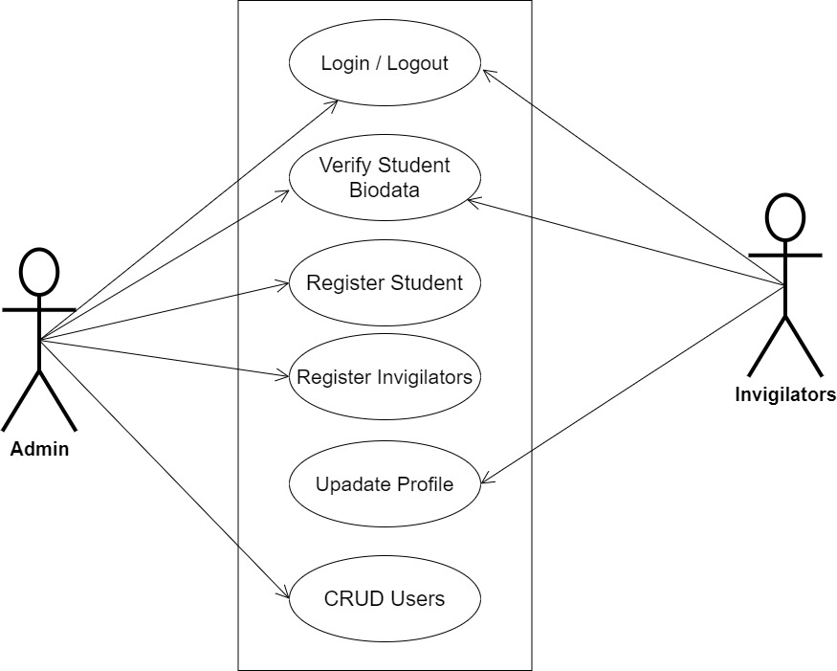

**Fig 3.1 System Use Case Diagram**

**3.2.2 CLASS DIAGRAM**

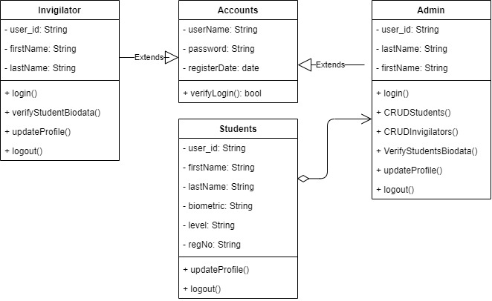Class diagrams are visual representations of a system's static structure and composition that adhere to the Unified Modeling Language principles (UML). It is one of the most often used UML diagram kinds. Class diagrams make it simpler to explain all of the classes, packages, and interfaces that comprise a system, as well as how these components are interconnected.

**Fig 3.2 Class Diagram**

**3.2.3 ACTIVITY DIAGRAM**

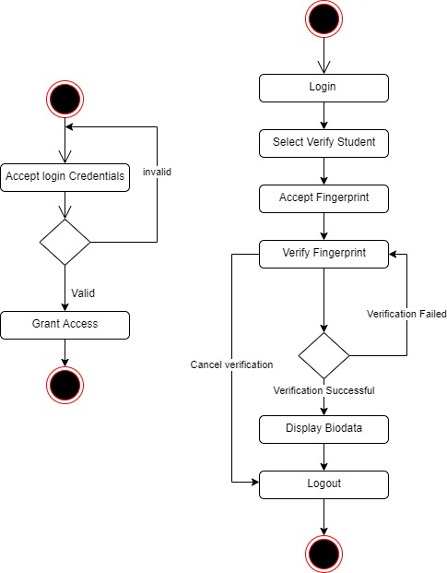

**Fig 3.4 Allocation Activity Diagram**

**Fig 3.3 Login Activity Diagram**

**3.4 CHOICE OF PROGRAMMING LANGUAGE**

This research work will be a desktop-based application and will be implemented on a relational database system, VB.net, and the FastCode (SDK) for finger identification to connect with Digital Persona U 4500 fingerprint scanner. The above are the modern languages used in implementing this system.

**REFERENCES**

Garko, A. B., & Ahmad, A. (2017). Design and modelling of a student verification system in an

examination in Nigeria. *International Journal of Advanced Academic Research*, *3*(7), 1-16.

https://www.mendeley.com/catalogue/a08dd69f-537a-3f19-b2563cf37987f014/#abstract-title

Koroloy, M. (2019). “*What is biometrics? 10 physical and behavioral identifiers that can be used for authentication. CSO Online*”.

https://www.csoonline.com/article/3339565/what-is-biometrics-and-why-collecting-biometric-data-is-risky.html

Haruna, U. S. (2018). sVeriTool: A Verification Tool for Preventing Impersonation of Students

in Examination Halls using Fingerprints. *SVeriTool African Journal of Computing & ICT Reference Format: U. S. Haruna*, *11*(2), 37–52.

https://afrjcict.net

Patrick, O., Karim, U., & Kenneth, D., (2019). “A Generic Certificate Verification

System for Nigerian Universities”*. International Journal of Computer Science and Mobile*

*Computing*, *8*(10), 137-148. https://ijcsmc.com/docs/papers/October2019/V8I10201924.pdf

Math, D. & Prasanna, K. M. (2019). Bio-Metric Enabled Examination Student Verification

System. *International Journal for Research in Applied Science and Engineering Technology, 7*(1), 603–610.

https://doi.org/10.22214/ijraset.2019.1097

Traoré, I., Nakkabi, Y., Saad, S., Sayed, B., Ardigo, J.D., de Faria Quinan, P.M. (2017). Ensuring

Online Exam Integrity Through Continuous Biometric Authentication. In: Traoré, I., Awad, A., Woungang, I. (eds) Information Security Practices. Springer, Cham. https://doi.org/10.1007/978-3-319-48947-6_6